Setting up DynamoDB
Step 1:
Look up DynamoDB in the AWS Console
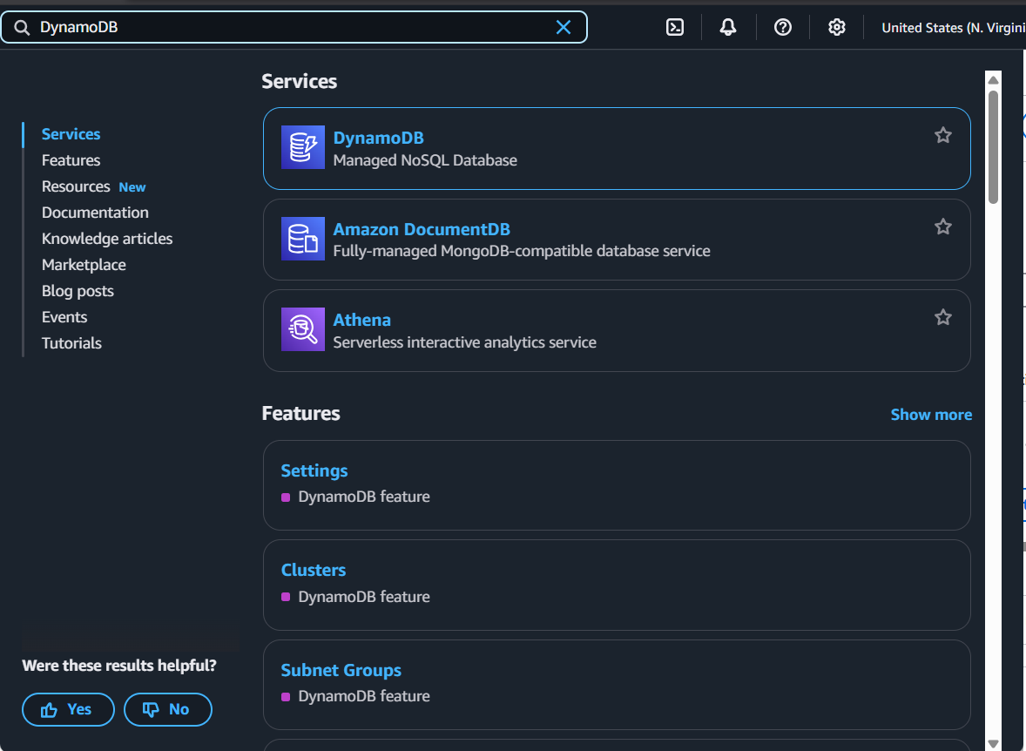
Step 2:
Click Create Table
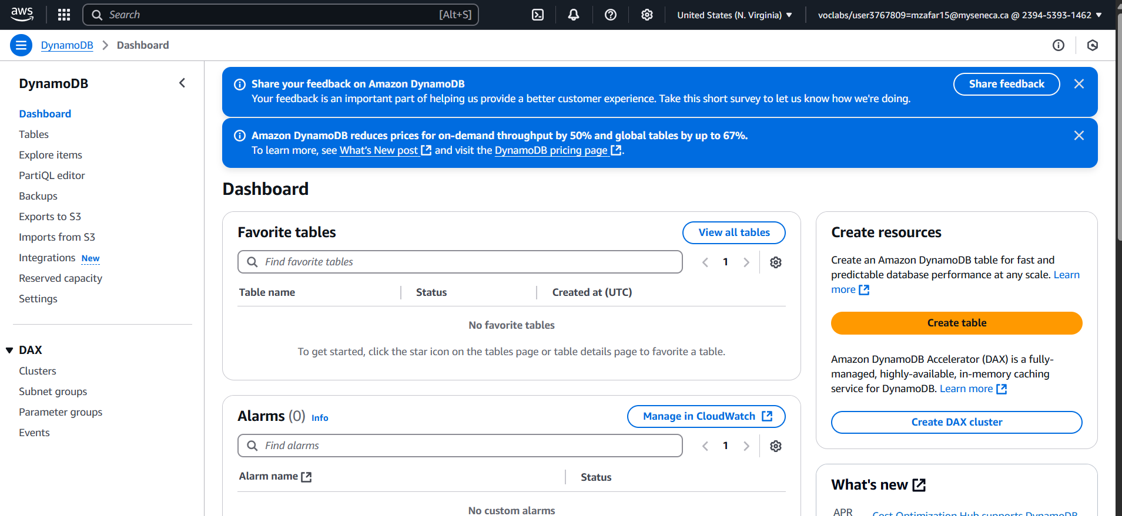
Step 3:
Set the Table Name
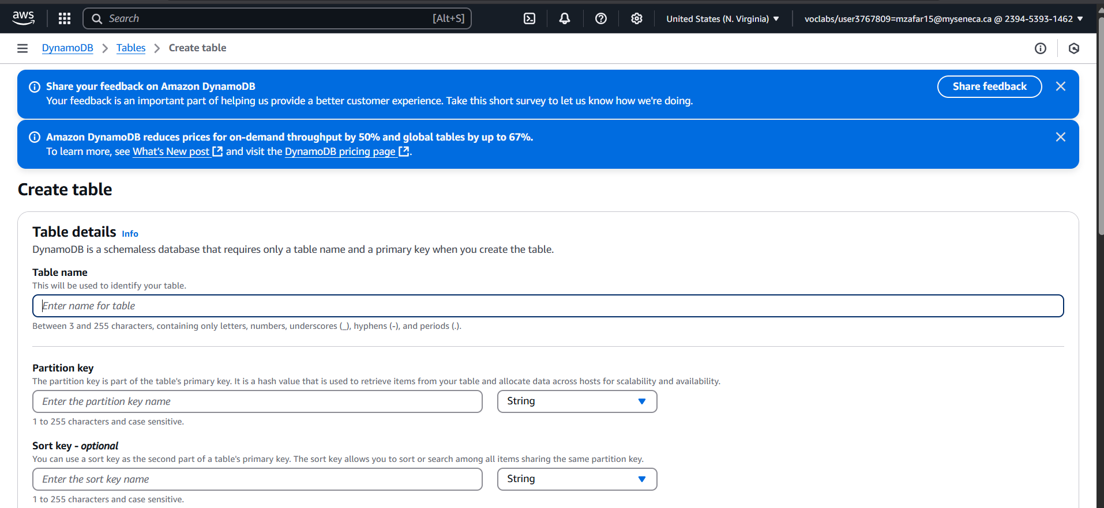
Step 4:
Set the primary/partition key of the table and sort key
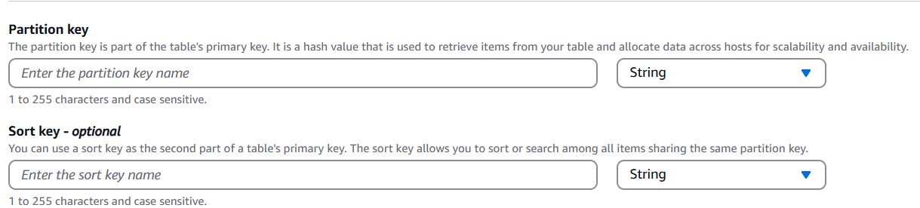

Optional:
Change the table settings
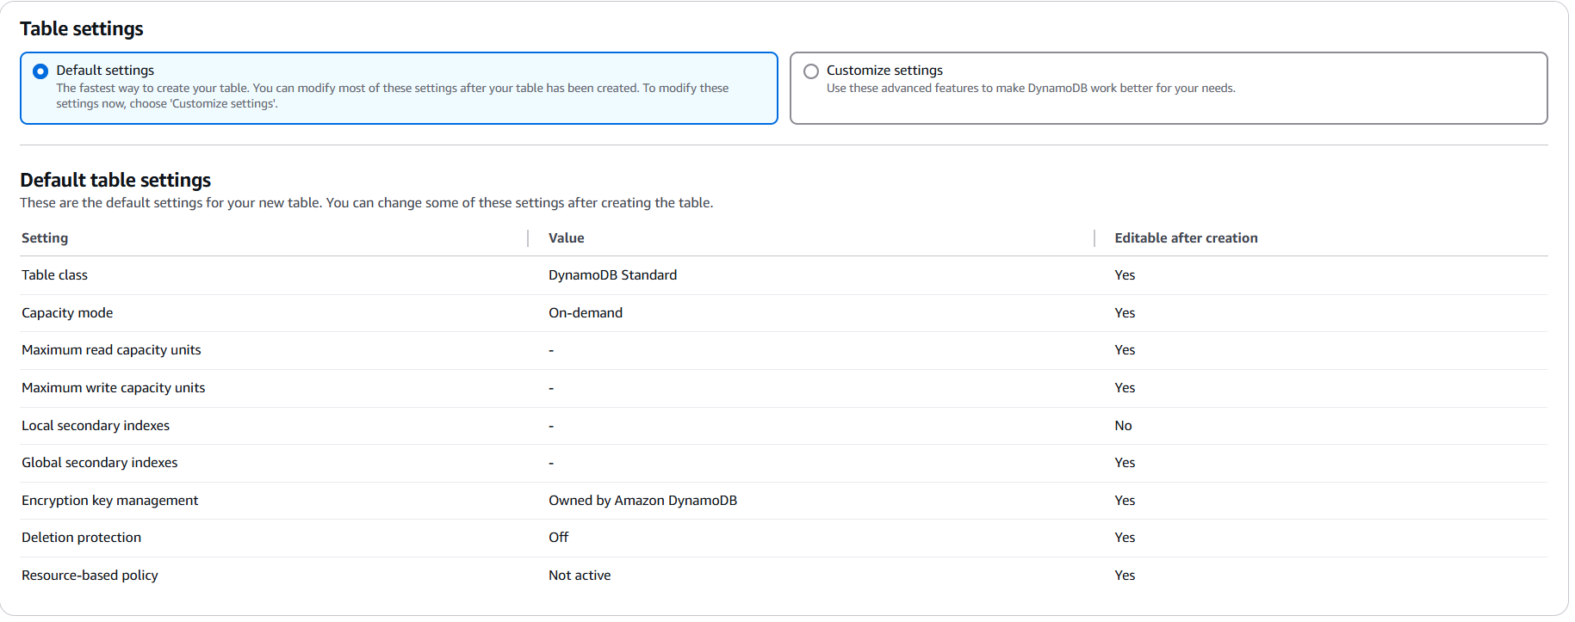
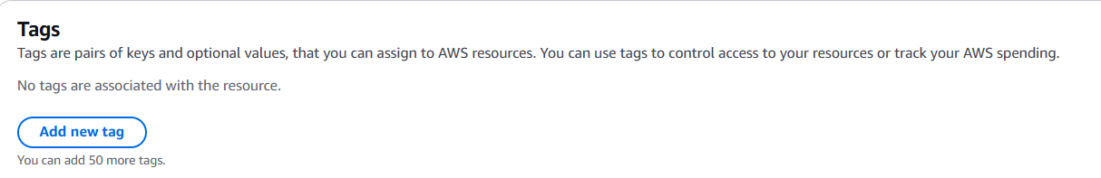
Step 5:
Click Create Table
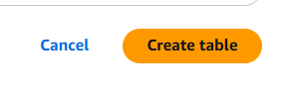

You can see the table from Tables
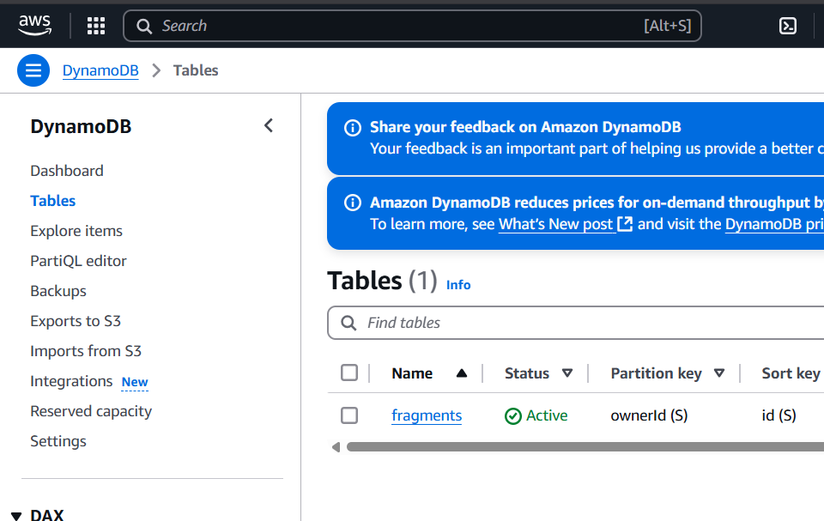
You can see the items from either the console or Explore Items
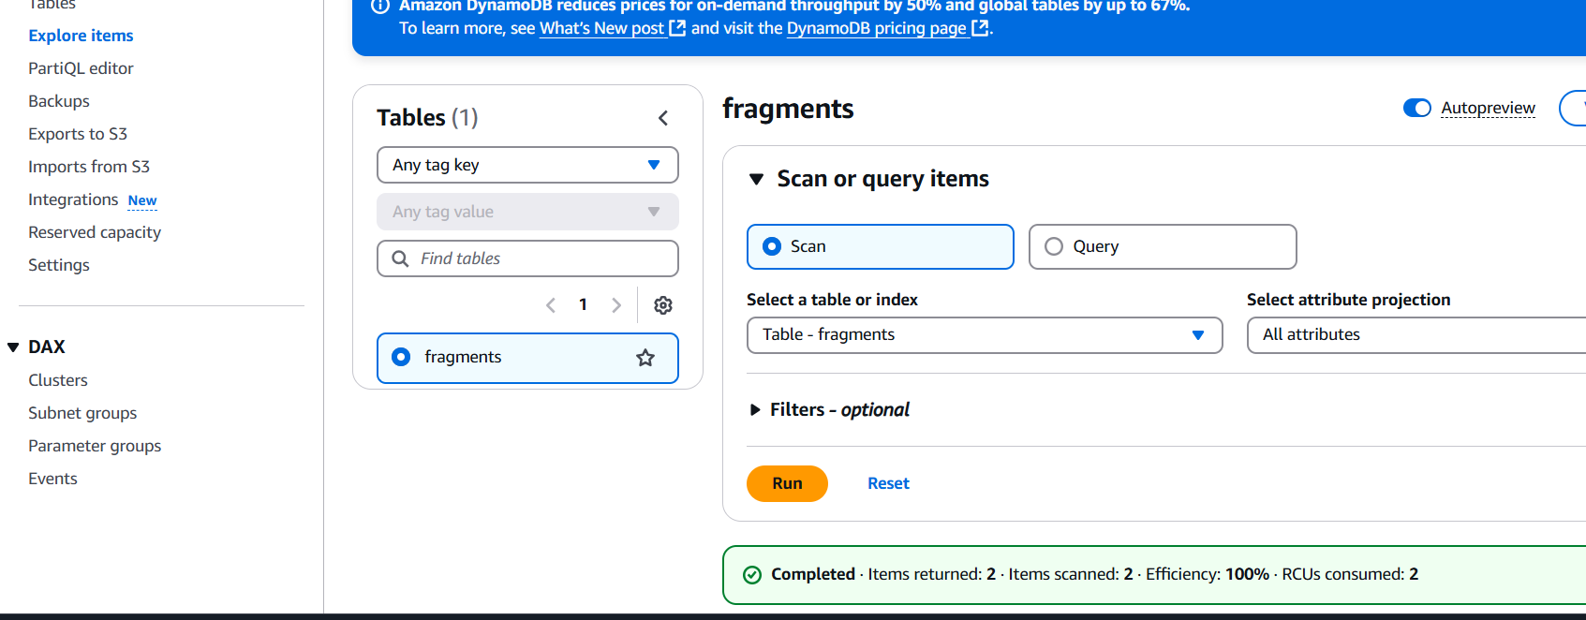
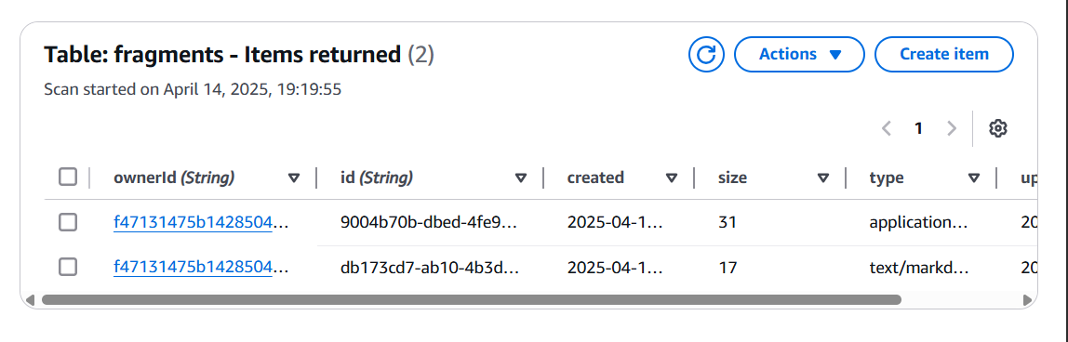

AWS Console
